SIMATS ENGINEERING (SAVEETHA SCHOOL OF ENGINEERING)
Department of Artificial Intelligence and Data Science
ASSESSMENT TOOL 3 – CODING CHALLENGE

Course Code: | DSA03 | Course Title: | Natural Language Processing
CO Assessed: | CO1 – Imitation (L1) | Assessment: | Assessment Tool 3 – Coding Challenge
Weightage: | 30% of CIA
CO5 Statement: | Analyse NLP models, regular expression patterns, finite state automata, morphological processing techniques and to interpret language processing. (BL-3)
Student Name: | GOGULA VIGNESH | Reg. No.: | 192424153
Section / Batch: | AI & DS | Date: | 01/AUG/2026

Code of Conduct
I G. Vignesh - 192424153 (Name / Reg No) certify that this submission is my original work and that I have adhered to the guidelines specified for this assessment. I understand that any violation of academic integrity rules will result in disciplinary action.
Signature of the Student: _________________________

Instructions
- Develop a complete and modular Python program that meets all the functional requirements specified in the coding challenge using appropriate algorithms, data structures, and programming practices.
- Test the program using multiple valid and invalid test cases, and clearly display the input, processing, and output to verify the correctness of the implementation.
- Follow standard coding practices by using meaningful variable names, proper indentation, comments, exception handling (where applicable), and upload the source code, sample outputs, and README file to the designated GitHub repository.
- Duration: 40 minutes.

Section / Topic | Focus | Q Nos
Regular Expression Pattern Matching | Regular Expressions, Basic Regular Expression Patterns | 1
Finite State Automata Implementation | Finite State Automata, Models and Algorithms | 2
Advanced Regular Expression Search | Regular Expressions, Basic Regular Expression Patterns | 3

Annexure A – Coding Challenge

Section 1: Intelligent Email and Password Validator using Regular Expressions
- Problem Statement:
A software company is developing a user registration system. Before creating an account, the system must validate user credentials based on predefined security policies.

Develop a Python application that validates:
Email Address
Password
Mobile Number

using Regular Expressions.

Validation Rules
Email
Must start with an alphabet.
May contain letters, digits, '.', '_' before '@'.
Domain should contain only alphabets.
Valid extensions: .com, .org, .edu, .net, .in
Password
Minimum 8 characters
At least one uppercase letter
At least one lowercase letter
At least one digit
At least one special character (@,#,$,%,&,!)
Mobile Number
Must contain exactly 10 digits.
First digit should be between 6–9.
Expected Output

Display:

Valid Email / Invalid Email
Strong Password / Weak Password
Valid Mobile Number / Invalid Mobile Number

Section 2: Design a Finite State Automata (FSA) Simulator
- Problem Statement

Develop a Python-based Deterministic Finite Automata (DFA) simulator.

The program should:
- Accept the DFA description
    - States
    - Input alphabet
    - Transition table
    - Initial state
    - Final state(s)
- Accept multiple input strings.
- Simulate state transitions.
- Display whether the string is Accepted or Rejected.
Example

Language:
Strings ending with "ab"

Input
abaab

Output
Transition Path:
q0 → q1 → q0 → q1 → q2
Accepted
Section 3: Smart Pattern Matching Engine using Regular Expressions
- Problem Statement

Develop a Python-based text search engine that performs pattern matching using Regular Expressions.

The system should support:
Word Search
Prefix Search
Suffix Search
Date Search
Phone Number Search
Hashtag Search
Mention (@username) Search

Example Input
Meeting on 12/09/2026
Call 9876543210
#NLP
@OpenAI
natural language processing

User Menu
1.Search Date
2.Search Phone Number
3.Search Hashtag
4.Search Mention
5.Search Prefix
6.Search Suffix

Expected Output
Display all matching patterns based on user selection.

Annexure B – Aim, Algorithm, Code and Sample Input/Output

Question 1: Intelligent Email and Password Validator using Regular Expressions
Aim
To develop a Python program that validates an Email Address, a Password, and a Mobile Number entered by a user, based on predefined security policies, using Regular Expressions.
Algorithm
1. Start.
2. Import the re module for regular expression operations.
3. Define a regex pattern for Email: must start with an alphabet, may contain letters, digits, '.' and '_' before '@', the domain must contain only alphabets, and the extension must be one of .com, .org, .edu, .net, .in.
4. Define a regex pattern for Password: minimum 8 characters, containing at least one uppercase letter, one lowercase letter, one digit, and one special character from (@ # $ % & !).
5. Define a regex pattern for Mobile Number: exactly 10 digits, with the first digit between 6 and 9.
6. Accept the Email, Password, and Mobile Number as input from the user.
7. Match the Email input against the email pattern using re.match(); print "Valid Email" if it matches, else print "Invalid Email".
8. Match the Password input against the password pattern; print "Strong Password" if it matches, else print "Weak Password".
9. Match the Mobile Number input against the mobile pattern; print "Valid Mobile Number" if it matches, else print "Invalid Mobile Number".
10. Repeat steps 6–9 for multiple test cases if required.
11. Stop.
Python Code
import re

def validate_email(email):
pattern = r'^[A-Za-z][A-Za-z0-9._]*@[A-Za-z]+\.(com|org|edu|net|in)$'
return bool(re.match(pattern, email))

def validate_password(password):
pattern = r'^(?=.*[a-z])(?=.*[A-Z])(?=.*\d)(?=.*[@#$%&!])[A-Za-z\d@#$%&!]{8,}$'
return bool(re.match(pattern, password))

def validate_mobile(mobile):
pattern = r'^[6-9]\d{9}$'
return bool(re.match(pattern, mobile))

def main():
email = input("Enter Email: ")
password = input("Enter Password: ")
mobile = input("Enter Mobile Number: ")

print("Valid Email" if validate_email(email) else "Invalid Email")
print("Strong Password" if validate_password(password) else "Weak Password")
print("Valid Mobile Number" if validate_mobile(mobile) else "Invalid Mobile Number")

if __name__ == "__main__":
main()
Sample Input
Email: john_doe@gmail.com
Password: John@123
Mobile Number: 9876543210
Sample Output
Valid Email
Strong Password
Valid Mobile Number

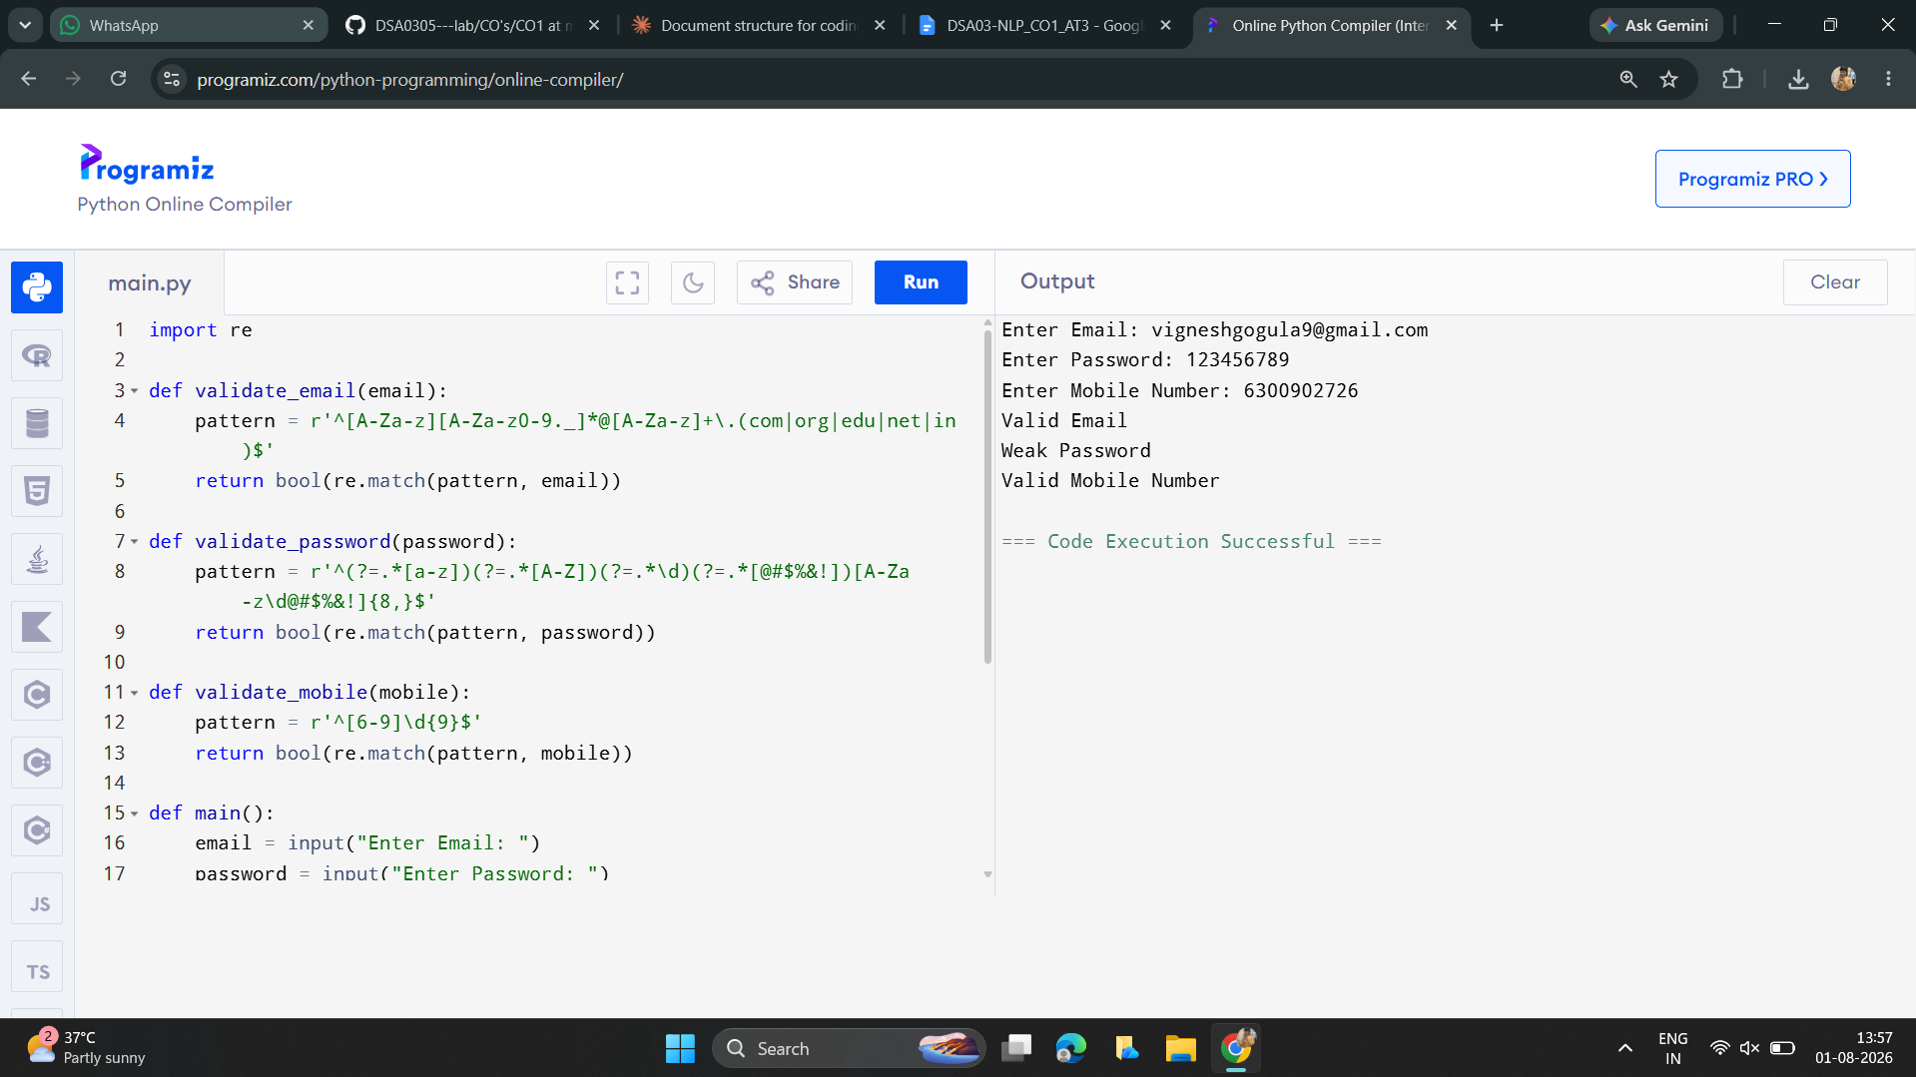

Question 2: Design a Finite State Automata (FSA) Simulator
Aim
To design and implement a Python-based Deterministic Finite Automata (DFA) simulator that accepts a DFA description (states, alphabet, transition table, initial state, final states) and multiple input strings, simulates the state transitions, and displays whether each string is Accepted or Rejected.
Algorithm
1. Start.
2. Define the DFA components: set of states, input alphabet, transition table, initial state, and set of final states.
3. Accept an input string to be tested.
4. Set current_state to the initial state and record it in the transition path.
5. For every character in the input string, find the next state using the transition table for (current_state, character) and append it to the path.
6. If no transition exists for the current state and symbol, mark the string as Rejected immediately.
7. After processing every character, check whether current_state belongs to the set of final states.
8. If yes, display the transition path and print "Accepted".
9. If no, display the transition path and print "Rejected".
10. Repeat steps 3–9 for multiple input strings.
11. Stop.
Python Code
def dfa_simulator(transitions, start_state, final_states, input_string):
current_state = start_state
path = [current_state]

for symbol in input_string:
if (current_state, symbol) not in transitions:
return path, False
current_state = transitions[(current_state, symbol)]
path.append(current_state)

return path, current_state in final_states

def main():
# DFA for strings ending with "ab"
transitions = {
('q0', 'a'): 'q1', ('q0', 'b'): 'q0',
('q1', 'a'): 'q1', ('q1', 'b'): 'q2',
('q2', 'a'): 'q1', ('q2', 'b'): 'q0',
}
start_state = 'q0'
final_states = {'q2'}

test_string = input("Enter a string to test: ")
path, accepted = dfa_simulator(transitions, start_state, final_states, test_string)

print("Transition Path:")
print(" -> ".join(path))
print("Accepted" if accepted else "Rejected")

if __name__ == "__main__":
main()
Sample Input
abaab
Sample Output
Transition Path:
q0 -> q1 -> q0 -> q1 -> q2
Accepted
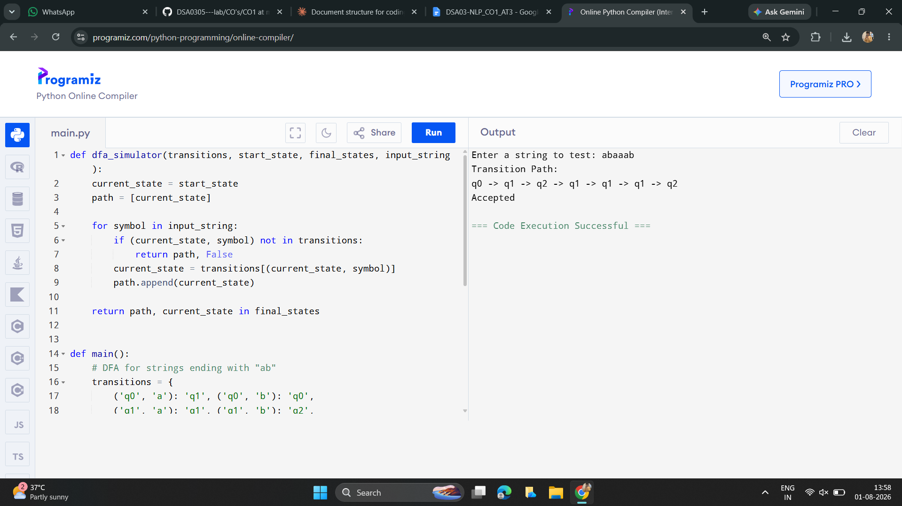

Question 3: Smart Pattern Matching Engine using Regular Expressions
Aim
To develop a Python-based text search engine that uses Regular Expressions to perform Word, Prefix, Suffix, Date, Phone Number, Hashtag, and Mention (@username) searches on a given block of text.
Algorithm
1. Start.
2. Import the re module.
3. Store the given text (containing dates, phone numbers, hashtags, mentions, and words) as a string.
4. Define regex patterns for each search type: Date (\d{1,2}/\d{1,2}/\d{4}), Phone Number (\d{10}), Hashtag (#\w+), Mention (@\w+), Prefix (given prefix followed by \w*), and Suffix (\w* followed by the given suffix).
5. Display a menu with the options: 1.Search Date, 2.Search Phone Number, 3.Search Hashtag, 4.Search Mention, 5.Search Prefix, 6.Search Suffix.
6. Accept the user's menu choice.
7. Apply re.findall() on the text using the pattern that corresponds to the chosen option (accept an extra prefix/suffix string from the user if options 5 or 6 are chosen).
8. Display all matching patterns found in the text.
9. Repeat steps 6–8 until the user chooses to exit.
10. Stop.
Python Code
import re

text = """Meeting on 12/09/2026
Call 9876543210
#NLP
@OpenAI
natural language processing"""

def search_date(t):
return re.findall(r'\d{1,2}/\d{1,2}/\d{4}', t)

def search_phone(t):
return re.findall(r'\b\d{10}\b', t)

def search_hashtag(t):
return re.findall(r'#\w+', t)

def search_mention(t):
return re.findall(r'@\w+', t)

def search_prefix(t, prefix):
return re.findall(r'\b' + re.escape(prefix) + r'\w*', t)

def search_suffix(t, suffix):
return re.findall(r'\w*' + re.escape(suffix) + r'\b', t)

def main():
menu = "1.Search Date\n2.Search Phone Number\n3.Search Hashtag\n" \
"4.Search Mention\n5.Search Prefix\n6.Search Suffix"
print(menu)
choice = input("Enter your choice: ")

if choice == '1':
print(search_date(text))
elif choice == '2':
print(search_phone(text))
elif choice == '3':
print(search_hashtag(text))
elif choice == '4':
print(search_mention(text))
elif choice == '5':
print(search_prefix(text, input("Enter prefix: ")))
elif choice == '6':
print(search_suffix(text, input("Enter suffix: ")))
else:
print("Invalid choice")

if __name__ == "__main__":
main()
Sample Input
Choice: 3 (Search Hashtag)
Sample Output
['#NLP']
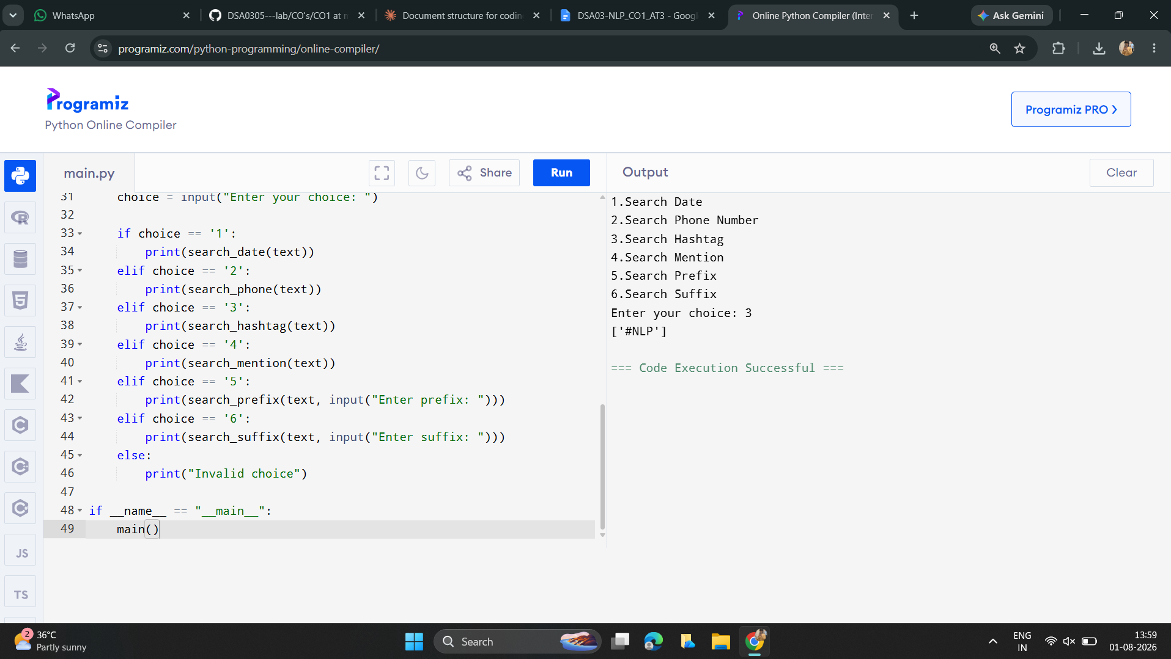

Rubrics for Calculation
Criteria | Weightage | Level 4 – Exemplary | Level 3 – Proficient | Level 2 – Developing | Level 1 – Beginning
Problem Understanding | 20% | Clearly understands problem constraints, edge cases, and competitive requirements | Understands problem with minor gaps in constraints | Partial understanding; misses key constraints | Misinterprets problem or constraints
Algorithm | 25% | Selects optimal algorithm with best time and space complexity for competitive constraints | Uses efficient algorithm with minor scope for improvement | Uses basic/inefficient approach | No clear algorithmic approach
Code Implementation | 20% | Writes correct, efficient, and clean code that passes all constraints | Code works with minor errors or inefficiencies | Partially correct code; fails for some cases | Code does not execute or gives incorrect results
Competitive Performance | 20% | Solves problem within time limits and handles large inputs effectively | Solves within acceptable time with minor delays | Struggles with time limits or larger inputs | Unable to solve within time constraints
Test Case Handling | 15% | Handles all test cases including edge and hidden cases | Handles most test cases | Misses important edge cases | Fails on multiple test cases

Q. No. / Criteria | Problem Understanding | Algorithm | Code Implementation | Competitive Performance | Test Case Handling | Sub. Total | Total %
1
2
3

Faculty In-charge | Course Coordinator | Program Director
Signature: _______________ | Signature: _______________ | Signature: _______________
Date: ___________________ | Date: ___________________ | Date: ___________________

